Wall Lamp

Version 1.0

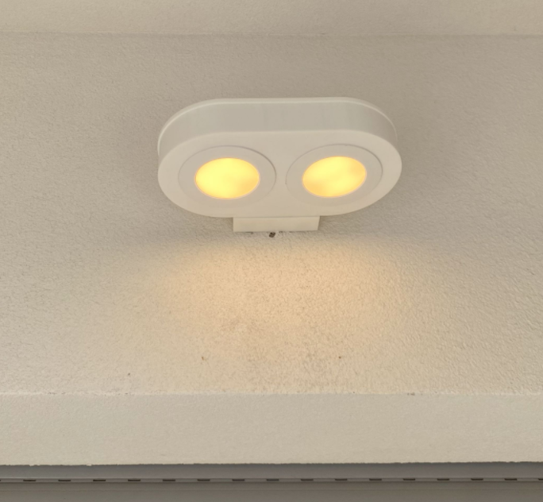

Project Goals

Sketches

3D Models

3D Printer Layout

Wall Body
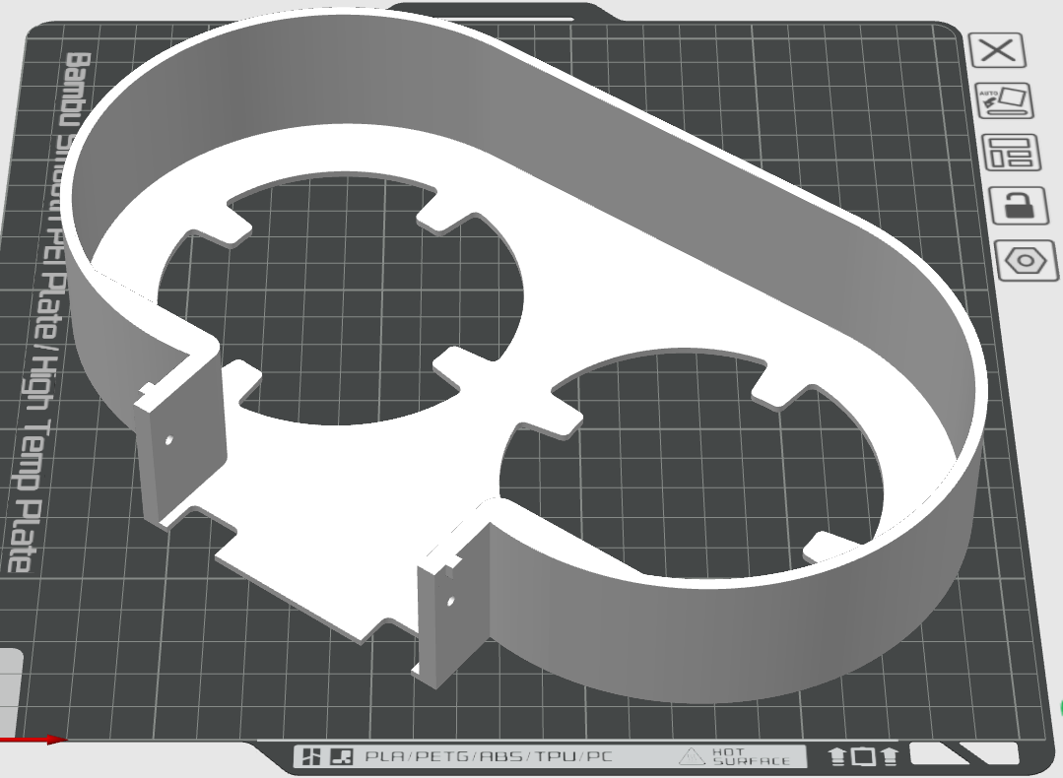

Cover
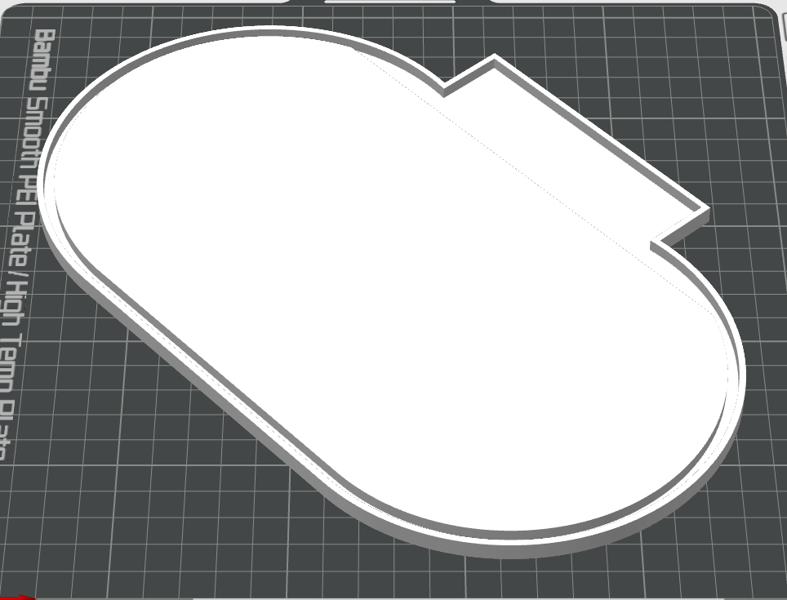

Wall Mount
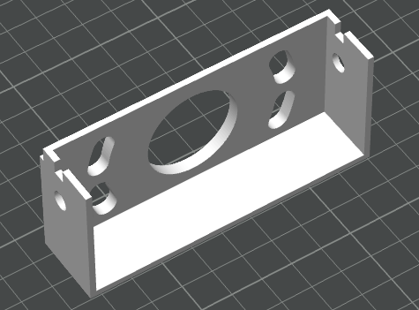

Final Result

